Task 1

Network diagram

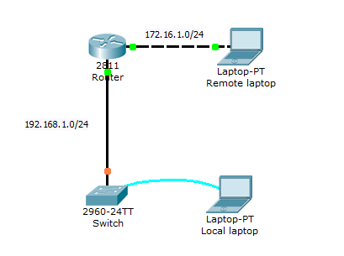

Lab instructions

This lab will test your ability to configure basic settings such as hostname, motd banner, encrypted passwords, and terminal options on a Cisco Catalyst 2960 switch simulated in Packet Tracer 7 & above version.

1. Use the local laptop connect to the switch console and configure the laptop with the right parameters for console access to the Cisco 2960 Catalyst switch. Configure Switch hostname as LOCAL-Router
2. Configure the message of the day as "Unauthorized access is forbidden"
3. Configure the password for privileged mode access as "cisco". The password must be md5 encrypted
4. Configure password encryption on the switch using the global configuration command
5. Configure CONSOLE access with the following settings :  
   - Login enabled  
   - Password : ciscoconsole  
   - History size : 15 commands  
   - Timeout : 6'45''  
   - Synchronous logging
6. Configure TELNET access with the following settings :  
   - Login enabled  
   - Password : ciscotelnet  
   - History size : 15 commands  
   - Timeout : 8'20''  
   - Synchronous logging
7. Configure the IP address of the switch as 192.168.1.2/24 and its default gateway IP (192.168.1.1).
8. Test telnet connectivity from the Remote Laptop using the telnet client.